The Effect of Science on Cancer Treatment

By Jamie Coulson

Cancer is of the most dangerous illnesses known to man. In 2016 alone 130,466 new cancer cases were diagnosed and 46,880 people died from cancer (Australian Government, 2016).

A cancer cell is formed when a regular cell is mutated and then the cancer cell starts spreading uncontrollable. This will eventually grow into a tumour which forms on body once this tumour grows big enough it then allows for cancer cells to enter the bloodstream and travel to other parts of the body.

Apoptosis is a process of a programmed cell death. It is triggered by characteristic cell changes (morphology) and the loss of life. Apoptosis is a cells only defence against cellular mutation. However a cell is able to mutate when the nucleus is mutated and this system is shut down before it can even be set off. This is how cancer cells are able to form (NCBI, 2002).

Cancer can be caused by many things raging form habits (i.e. smoking) to inheriting it genetically from parents or ancestors. The most common cause of cancer and cancer deaths is smoking causing one in every nine people cancer is caused by smoking and a further one in five cancer deaths is caused by smoking (Cancer Council, 2016).

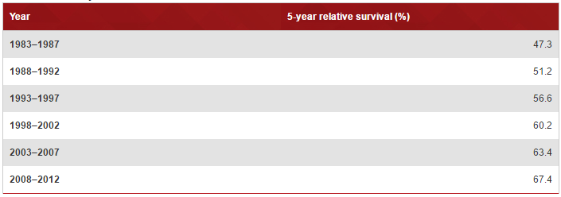

Scientists have not discovered the cure to cancer because of its uniqueness but many foundations (i.e. Cancer Council) have been set up to raise money to help speed up the process of finding a cure. Through this research, scientists have found made massive discoveries in the treatment of cancer which has greatly increased the life expectancy of people that get cancer. In 1983-1987 the 5 year survival expectancy was at 47.3% but in 2008-2012 the percentage has greatly increased from 47.3% to 67.4% (Figure 1) (Australian Government, 2016).

Figure ) 5 year survival expectancy (Australian Government, 2016)

Although there is no cure to cancer scientists have been able to find ways to reduce the spread/amount of cancer (MedicineNet, N/A). The most commonly used method is called chemotherapy. Chemotherapy (also called chemo) is a cancer treatment that injects drugs into the bloodstream to destroy cancer cells. Chemotherapy was discovered during World War 2 that soldiers exposed to nitrogen mustard developed significantly less white blood cells. This then lead researches to test if chemicals in mustard gas could be used to halt the growth and spread of rapidly dividing like cancer (Mandal, 2014). In the 1940s two Yale pharmacologists, Alfred Gilman and Louis Goodman examined the effects of the mustard gas agents in treating lymphoma. First they established lymphomas in mice to show that the agents of the mustard gas could treat lymphoma. Then with a thoracic surgeon called Gustavo Linskog and injected a less volatile version into a patient with nonHodgkin’s lymphoma.